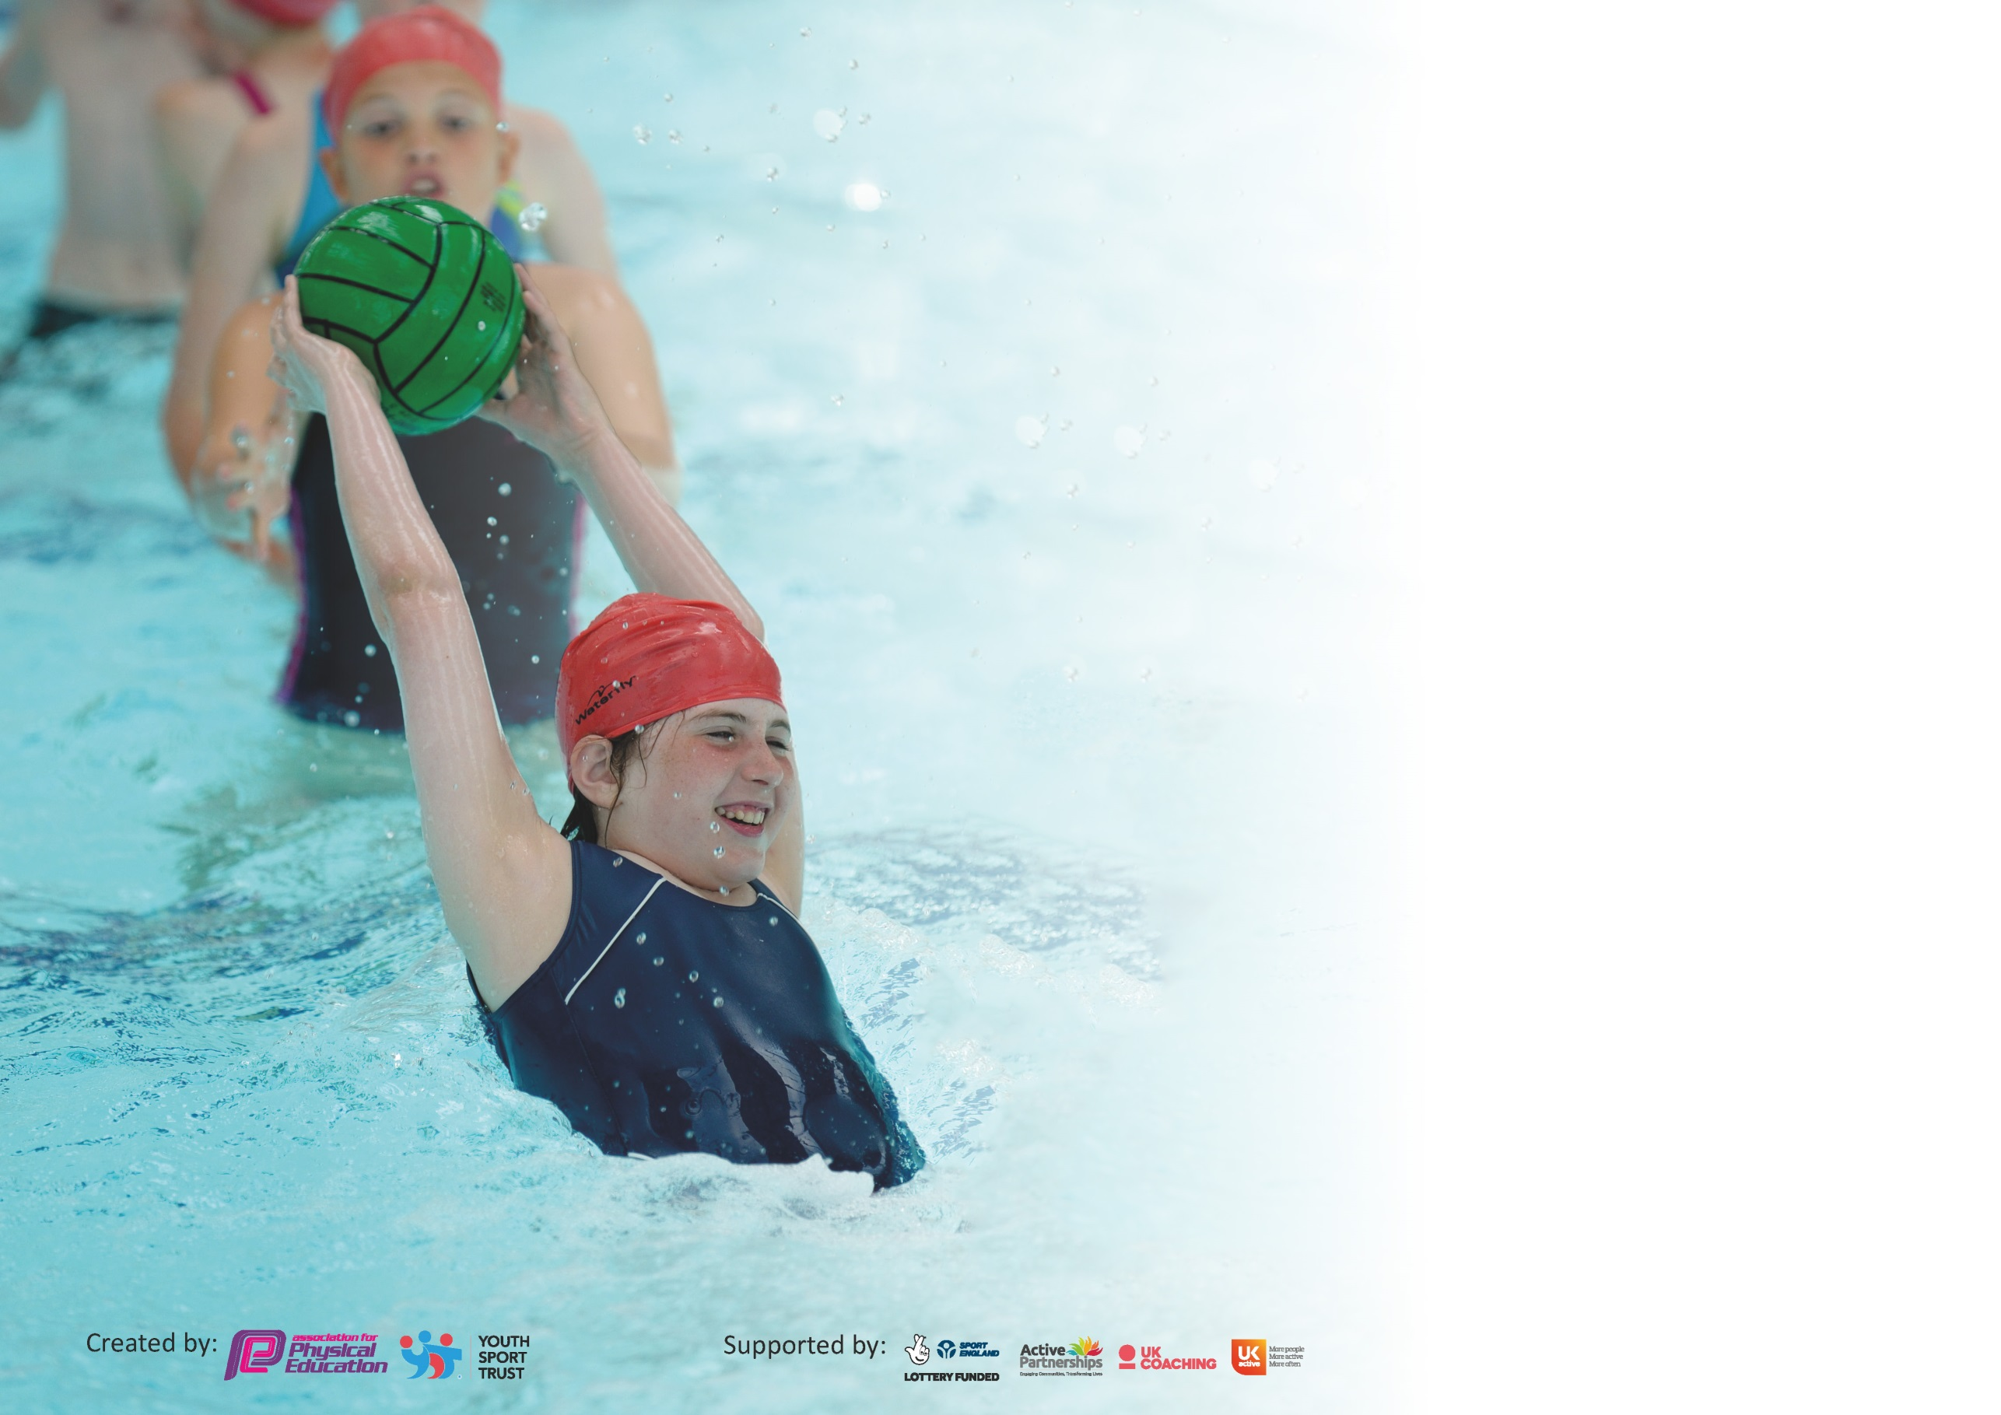

It is important that your grant is used effectively and based on school need. The Education Inspection Framework (Ofsted 2019 p64) makes clear there will be a focus on ‘whether leaders and those responsible for governors all understand their respective roles and perform these in a way that enhances the effectiveness of the school’.

Under the Quality of Education criteria (p41) inspectors consider the extent to which schools can articulate their curriculum (INTENT), construct their curriculum (IMPLEMENTATION) and demonstrate the outcomes which result (IMPACT).

To assist schools with common transferable language this template has been developed to utilise the same three headings which should make your plans easily transferable between working documents.

Schools must use the funding to make additional and sustainable improvements to the quality of Physical Education, School Sport and Physical Activity (PESSPA) they offer. This means that you should
use the Primary PE and Sport Premium to:

- Develop or add to the PESSPA activities that your school already offer
- Build capacity and capability within the school to ensure that improvements made now will benefit pupils joining the school in future years

Please visit gov.uk for the revised DfE guidance including the 5 key indicators across which schools should demonstrate an improvement. This document will help you to review your provision and to report your spend. DfE encourages schools to use this template as an effective way of meeting the reporting requirements of the Primary PE and Sport Premium.

We recommend you start by reflecting on the impact of current provision and reviewing the previous spend.

Schools are required to publish details of how they spend this funding as well as on the impact it has on pupils’ PE and sport participation and attainment by the end of the summer term or by 31st July 2021 at the latest.

We recommend regularly updating the table and publishing it on your website throughout the year. This evidences your ongoing self-evaluation of how you are using the funding to secure maximum, sustainable impact. Final copy must be posted on your website by the end of the academic year and no later than the 31st July 2021. To see an example of how to complete the table please click HERE.

Support for review and reflection - considering the 5 key indicators from DfE, what development needs are a priority for your setting and your pupils now and why? Use the space below to reflect on previous spend and key achievements and areas for development.

Key achievements to date until July 2022: | Areas for further improvement and baseline evidence of need:
More in house competitions run at school, all year groups involved in sports day as mixed ages teams. KS2 cross country, cricket and rounders tournaments.  Inter schools competition returned and were popular amongst the children – all children in KS2 took part in out of school competitions.  All year groups invited and attended afterschool sports clubs – attendance was from R to Y6.  Differing sports clubs after school including dodgeball and mindfulness. | Swimming provision needs to be arranged for the forthcoming year – who, when and where and for how long. Training for staff also needs seeking.  More opportunity for KS 1 children to compete/try out sports as part of a cluster of schools.  All teachers require PE Pal assessment training – PE Pal creators need to deliver face to face CPD following cancellation.  Gymnastics and Dance planning needs consideration – space and safety

Meeting national curriculum requirements for swimming and water safety.
What percentage of your current Year 6 cohort swim competently, confidently and proficiently over a distance of at least 25 metres?  N.B. Even though your pupils may swim in another year please report on their attainment on leaving  primary school at the end of the summer term 2022. | 87.5%  7/8
What percentage of your current Year 6 cohort use a range of strokes effectively [for example, front crawl, backstroke and breaststroke]? | 62.5%  5/8 Year 6 children
What percentage of your current Year 6 cohort perform safe self-rescue in different water-based situations? | 62.5%  5/8 Year 6 children
Schools can choose to use the Primary PE and Sport Premium to provide additional provision for swimming but this must be for activity over and above the national curriculum requirements. Have you used it in this way? | Yes/No

Action Plan and Budget Tracking
Capture your intended annual spend against the 5 key indicators. Clarify the success criteria and evidence of impact that you intend to measure to evaluate for pupils today and for the future.

Academic Year: 2021/22 | Total fund allocated: £16,683 | Date Updated: September 2021
Key indicator 1: The engagement of all pupils in regular physical activity – Chief Medical Officer guidelines recommend that primary school pupils undertake at least 30 minutes of physical activity a day in school |  |  |  | Percentage of total allocation:
 |  |  |  | £5500 (32%)
Intent | Implementation |  | Impact
Your school focus should be clear what you want the pupils to know and be able to do and about  what they need to learn and to consolidate through practice: | Make sure your actions to achieve are linked to your intentions: | Funding allocated: | Evidence of impact: what do pupils now know and what can they now do? What has changed?: | Sustainability and suggested next steps:
For all children in KS1 to take part in an active Forest school session each week to encourage greater physical development.  For all children to be physically active during their break and lunch time throughout the year.  Provide different opportunities for children in KS2 to be active outside of school. | Teacher plan sessions to be active.  Needs additional TA to be present at the session  Session timings need to mirror KS2 PE session.  Store equipment so that children can access independently and freely.  Train older children to be buddies at break time to encourage the use of equipment.  Arrange a day out to Climbing wall – children experience new activity and linked the sense of achievement through it. | Cost of additional TA hours – one afternoon each week. (£2500)  Rental of the field for school access throughout year. (£2000)  £1000 – cost of coach, cost of half day activity for all children in Sapling and Oak. | Children from R, Y1 and Y2 went each Monday to Forest school – this has upped the amount of physical activity for all EYFS and KS1 children through the walk to and from the site and the types of activities they do there – balancing, pulling, pushing, climbing. The time slot works really well as KS2 children are taught in smaller groups.  Year 6 children took part in a Skipping workshop and brought the enthusiasm for skipping back to school – they modelled to younger children and skipping has really taken off around the playground.  The climbing wall and reaction activities were really well received – many children went feeling nervous of the climbing and caving experience but everyone tried it and felt good about their achievements. | Does the Forest school set up work for next academic year?  New Children need to take up the Play buddie role for break times.
Key indicator 2: The profile of PESSPA being raised across the school as a tool for whole school improvement |  |  |  | Percentage of total allocation:
 |  |  |  | £2300 (13%)
Intent | Implementation |  | Impact
Your school focus should be clear what you want the pupils to know and be able to do and about what they need to learn and to  consolidate through practice: | Make sure your actions to achieve are linked to your intentions: | Funding allocated: | Evidence of impact: what do pupils now know and what can they now do? What has changed?: | Sustainability and suggested next steps:
For the coverage of PE skills to be full and throughout across the PE curriculum from R to Y6.  For the pupils to be involved in competitive activity within school and outside of school.  To celebrate involvement of pupils participation in regularly updated Sports board. | Use PE Pal units to inform curriculum planning for each year group.  Monitor the delivery of units – by who and when – which year group focus.  Enquire with local sports clusters as to position of offer post COVID.  Consider making own links with local primaries for competitive opportunities.  Space allocated in school.  Reports of matches, events written for newsletter and the display by teachers and pupils. | Time for subject leader to look at LTPs for each class. (£200 x3)  Cost of participation £1400 SWR  £250 Kingshill  Admin costs- £50 | Pupils received a full year of PE teaching this year -with no restrictions. LTP still need looking at to ensure the coverage is relevant and links with competitive sport opportunities outside of school. I only managed one day of PE time.  We were able to take part in most SWR events and some Kingshill events – only KS2 had the opportunity as some events were cancelled by the cluster and not rearranged.  Sports board updated with children’s achievements outside school at their own clubs and within school. | PE leadership needs to have more time to look at LTPs and make sure the two year cycle provides opportunity for depth of skill development.  Push for KS1 opportunites next academic year.  Bigger board space?

Key indicator 3: Increased confidence, knowledge and skills of all staff in teaching PE and sport |  |  |  | Percentage of total allocation:
 |  |  |  | £5034 (30%)
Intent | Implementation |  | Impact
Your school focus should be clear  what you want the pupils to know  and be able to do and about  what they need to learn and to  consolidate through practice: | Make sure your actions to  achieve are linked to your  intentions: | Funding  allocated: | Evidence of impact: what do  pupils now know and what  can they now do? What has  changed?: | Sustainability and suggested  next steps:
For all staff to use the PE Pal units to deliver quality PE sessions and progress in pupil skill is evident throughout the year.  For staff to take increasing ownership over the delivery of the PE units. | Staff confident to deliver exciting PE sessions.  Staff confident in knowledge of PE skills and how they develop.  Rotating PE sessions so that all staff get the opportunity to teach alongside the PE Pal coach. | Annual PE Pal licence fee £900  Support of PE Pal teacher £109 per session (£3924).  School membership to Youth Sport Trust (£210) | Staff in Sapling (teacher and HLTA) and teacher and student teacher had training with Atlas coach. Teacher confidence growing and use of PE Pal is now universal across the school.  Children are familiar with format of the PE Pal sessions and are beginning to help with organisation of equipment. | Consider rotation of staff caching? Teaching each other and supported by staff having already receiving the training.  Dan from PE Pal owes us training on the system and needs updating for new content. Consider how new content can be incorporated into LTP.
Key indicator 4: Broader experience of a range of sports and activities offered to all pupils |  |  |  | Percentage of total allocation:
 |  |  |  | £1050 (6%)
Intent | Implementation |  | Impact
Your school focus should be clear  what you want the pupils to know  and be able to do and about  what they need to learn and to  consolidate through practice: | Make sure your actions to  achieve are linked to your  intentions: | Funding  allocated: | Evidence of impact: what do  pupils now know and what  can they now do? What has  changed?: | Sustainability and suggested  next steps:
To seek active afterschool club opportunities that are varied and diverse and appeal to all children.  Reach out to local sports clubs and promote local clubs amongst the school community.  Additional achievements: | Source outside providers that offer an expertise or different experience.  Ask for parental expertise – can they offer a club.  Make links with FG Rovers, local rugby and hockey clubs, fencing etc.  Ask school community for links they might have. | £1000  £50 | I researched outside providers and found a rugby coach who ran multi skills to all ages – this was a popular club for all children and children joined from R to Y6. We encouraged children to all try the club and were able to offer payment subsidies for some whose siblings joined in. Forest Green Rivers offered us a lunch time club for football which helped resolve conflicts and make play more amicable. One of our parents also offered to help run the rugby club when our provider pulled out and a mindfulness club was set up to support well-being. | Encourage parents to offer clubs that support the events we planning on entering a team into.  Sign Forest green Rover young ambassadors up for next academic year.  Seek further opportunities for links with professional clubs – Gloucester rugby?

Key indicator 5: Increased participation in competitive sport |  |  |  | Percentage of total allocation:
 |  |  |  | £1050 (6%)
Intent | Implementation |  | Impact
Your school focus should be clear  what you want the pupils to know  and be able to do and about  what they need to learn and to  consolidate through practice: | Make sure your actions to  achieve are linked to your  intentions: | Funding  allocated: | Evidence of impact: what do  pupils now know and what  can they now do? What has  changed?: | Sustainability and suggested  next steps:
For all pupils to take part in sporting competition within the school community.  For all children to take part in competitive sport with local schools.  For all KS2 children to experience professional sport by watching a match or visiting a sports location. | To establish ‘House’ tournaments that are visited annually and across keystages.  Arrange trip to a stadium or to watch a sport being played.  Can local professional teams help us – Gloucester rugby, Forest Green Rovers, Swindon Town, Ice hockey in Cardiff. | Trophies purchased - £50  £1000 | House tournaments for Cricket and Rounders were organised this year – children from Y3-6 took part. The KS1 events outside of school all got cancelled but some able Y2 were able to participate in the Y3/4 rugby tournament outside of school.  R-Y2 also took aprt in the Tennis tournament run by school at a local court.  Year 4 were able to visit a cricket match in Bristol and watch LV insurance County cricket match as well as meet players and do an activity on the pitch. | How can KS1 be involved in house tournaments in addition to the Sports day?  Arrange this for other sports and take more children.

Signed off by
Head Teacher: | Caroline Musty
Date:
Subject Leader: | Sarah Thorogood
Date:
Governor: | Paula Bendle
Date:

