Subject | Term 1  Land Ahoy! | Term 2  Reach For The Stars | Term 3  What On Earth? | Term 4  The Prehistoric World | Term 5  Let’s Explore The UK | Term 6  Scrumdiddlyumpious!
English | Narrative:  Stories with familiar settings  Non Fiction:  letters  Poetry:  A study of a poet - Zephaniah | Narrative:  Traditional tales  Non Fiction:  Information texts  Poetry:  Classic poems | Narrative:  Books about fantasy  Non Fiction:  NCR  Poetry:  Poems by the same author | Narrative:  Books by the same illustrator  Non Fiction:  Recounts  Poetry:  Humorous poems | Narrative:  Stories from the recent past  Non Fiction:  Instructions and explanations  Poetry:  Poems on a theme: monsters | Narrative:  Legends-robin hood  Non Fiction:  Persuasive writing  Poetry:  Poems of the world - nature poems
SPAG  YR 2 | Use of capital letters, full stops, question marks and exclamation marks to demarcate sentences | Subordination (using when, if, that, because) and co-ordination (using or, and, but)  Expanded noun phrases for description and specification [for example, the blue butterfly, plain flour, the man in the moon]  English to turn adjectives into adverbs and the use of –ly in Standard | Correct choice and consistent use of present tense and past tense throughout writing  Use of the progressive form of verbs in the present and past tense to mark actions in progress [for example, she is drumming, he was shouting] | Formation of adjectives using suffixes such as –ful, –less  Use of the suffixes –er, –est in adjectives | How the grammatical patterns in a sentence indicate its function as a statement, question, exclamation or command  Formation of nouns using suffixes such as –ness, –er and by compounding [for example, whiteboard, superman] | Apostrophes to mark where letters are missing in spelling and to mark singular possession in nouns [for example, the girl’s name]  Commas to separate items in a list
Year 2  Phonics and spelling | 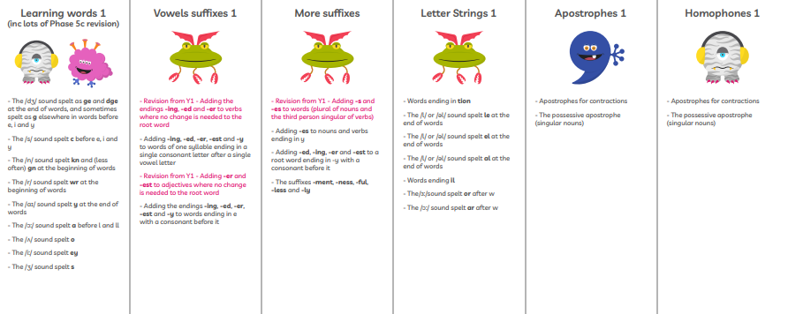
SPAG  Yr 3 | Use of the forms a or an according to whether the next word begins with a consonant or a vowel [for example, a rock, an open box] | Expressing time, place and cause using conjunctions [for example, when, before, after, while, so, because],  adverbs [for example, then, next, soon, therefore],  use the first 2 or 3 letters of a word to check its spelling in a dictionary | Introduction to paragraphs as a way to group related material  Headings and sub-headings to aid presentation  Use of the present perfect form of verbs instead of the simple past [for example, He has gone out to play contrasted with He went out to play] | Introduction to inverted commas to punctuate direct speech  write from memory simple sentences, dictated by the teacher, that include words and punctuation taught so far | prepositions [for example, before, after, during, in, because of]  Word families based on common words, showing how words are related in form and meaning [for example, solve, solution, solver, dissolve, insoluble] | Formation of nouns using a range of prefixes [for example super–, anti–, auto–]
Year 3 Spelling/ Phonics revision | 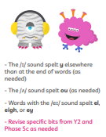 | 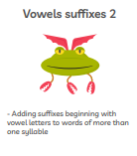 | 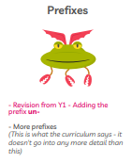 | 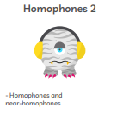 | 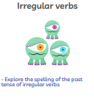 | 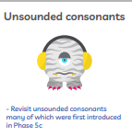
Maths | 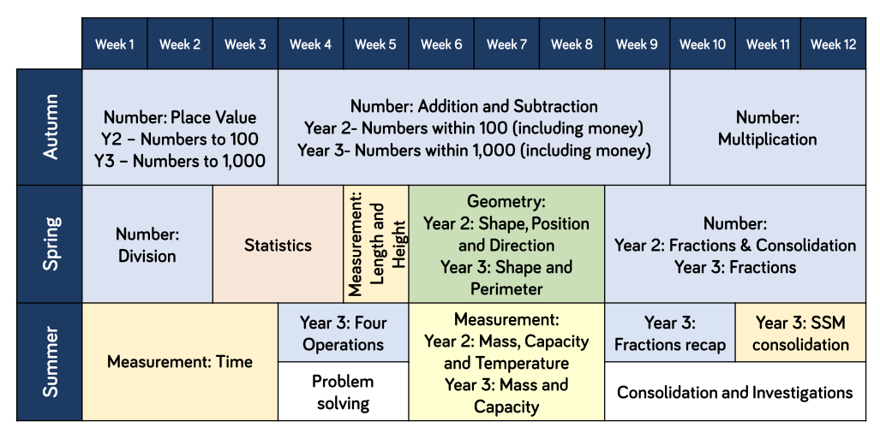
Science | Animals including humans Yr 2  • Notice that animals, including humans, have offspring which grow into adults.  • Investigate and describe the basic needs of animals, including humans, for survival (water, food and air).  • Describe the importance for humans of exercise, eating the right amounts of different types of food and hygiene. | Light Yr 3  • Recognise that they need light in order to see things and that dark is the absence of light.  • Notice that light is reflected from surfaces.  • Recognise that light from the sun can be dangerous and that there are ways to protect their eyes.  • Recognise that shadows are formed when the light from a light source is blocked by a solid object.  • Find patterns in the way that the size of shadows change.  Neil Armstrong (history) |  | Rocks and Soils Yr 3  • Compare and group together different kinds of rocks on the basis of their simple, physical properties.  • Relate the simple physical properties of some rocks to their formation (igneous or sedimentary).  • Describe in simple terms how fossils are formed when things that have lived are trapped within sedimentary rock.  • Recognise that soils are made from rocks and organic matter. |  | Animals including humans Yr 3  • Identify that humans and some animals have skeletons and muscles for support, protection and movement.  • Identify that animals, including humans, need the right types and amounts of nutrition, that they cannot make their own food and they get nutrition from what they eat.
Art | Drawing: Rembrandt  • Draw lines of different sizes and thickness.  • Colour (own work) neatly following the lines.  • Show pattern and texture by adding dots and lines.  • Show different tones by using coloured pencils. (Yr2)  • Use different hardnesses of pencils to show line, tone and texture  • Use hatching and cross hatching to show tone and texture. (yr3) |  | Collage  Surrealism - Dali  • Select and arrange materials for a striking  effect.  • Ensure work is precise.  • Use coiling, overlapping, tessellation, mosaic  and montage. (Yr3) |  | Textiles  Sonia Delaunay-orphism  • Use weaving to create a pattern.  • Join materials using glue and/or a stitch.  • Use plaiting.  • Use dip dye techniques. (Yr2)  • Colour fabric.  • Shape and stitch materials.  • Use basic cross stitch and back stitch. (Yr3)
DT |  | Materials:  • Cut materials accurately and safely by selecting appropriate tools.  • Measure and mark out to the nearest millimetre.  • Apply appropriate cutting and shaping techniques that include cuts within the perimeter of the material (such as slots or cut outs).  • Select appropriate joining techniques. (Yr 3) |  | Construction:  • Use materials to practise drilling, screwing, gluing and nailing materials to make and strengthen products. (Yr2)  • Choose suitable techniques to construct products or to repair items.  • Strengthen materials using suitable techniques.(Yr3) |  | Food:  • Cut, peel or grate ingredients safely and hygienically.  • Measure or weigh using measuring cups or electronic scales.  • Assemble or cook ingredients. (Yr2)  • Prepare ingredients hygienically using appropriate utensils.  • Follow a recipe. (yr3)  • Assemble or cook ingredients (controlling the temperature of the oven or hob, if cooking).  • Measure ingredients to the nearest gram accurately  (Yr 3)
History |  | Moon Landing and Neil Armstrong (Yr 2 topic)  • Describe historical events.  • Describe significant people from the past  • Observe or handle evidence to ask questions and find answers to questions about the past.  • Ask questions such as: What was it like for people? What happened? How long ago? (Yr 2) |  | Changes in Britain from the Stone Age to the Iron Age (Yr 3 topic)  • Use evidence to ask questions and find answers to questions about the past.  • Compare some of the times studied with those of other areas of interest around the world  • Use dates and terms to describe events.  • Use appropriate historical vocabulary to communicate, including:  • era  • change  • chronology.  (Yr 3) |  | Christopher Columbus  • Describe historical events.  • Describe significant people from the past. (Yr 2)  • Place events, artefacts and historical figures on a time line using dates. (Yr 3)
Geography | Magical Mapping Yr 2  • Name different types of maps and explain some key features of maps.  • Draw a simple sketch map of the school and local area. • Name the four points of a compass.  • Plan a simple route around the local area using key vocabulary. • Identify map symbols.  • Use an atlas to locate the four countries of the UK, capital cities and other key places.  • Use an atlas to locate the seven continents of the world.  • Use an atlas to locate the five major oceans of the world.  • Use aerial photographs to ‘view from above’ and recognise basic human and physical features  • Ask geographical questions – Where is it? What is this place like? How near/far is it? |  | Extreme Earth: Yr 3  • Use world maps, atlases and globes to identify the United Kingdom and its countries, as well as the countries, continents and oceans studied. (Yr 2)  • Explain own views about locations, giving reasons.  • physical geography, including: rivers, mountains, volcanoes and earthquakes and the water cycle.  • Ask and answer geographical questions about the physical and human characteristics of a location.  (Yr 3) |  | The UK Yr 3  • Name and locate counties and cities of the United  Kingdom, geographical regions and their identifying human and physical characteristics, including hills, mountains, cities, rivers, key topographical features and land-use patterns; and understand how some of these aspects have changed over time | Land Use Yr 3  • Use simple fieldwork and observational skills to study the geography of the school and the key human and physical features of its surrounding environment.  • Use aerial images and plan perspectives to recognise landmarks and basic physical features. (Yr 2)  • Name and locate counties and cities of the United  Kingdom, geographical regions and their identifying human and physical characteristics, including hills, mountains, cities, rivers, key topographical features and land-use patterns; and understand how some of these aspects have changed over time  • Use fieldwork to observe and record the human and physical features in the local area using a range of methods including sketch maps, plans and graphs and digital technologies.  • Use the eight points of a compass, four-figure grid references, symbols and key to communicate knowledge of the United Kingdom and the wider world.  (Yr 3)
Music | Hands, feet, heart,  Yr 2 unit 1 | Christmas Performance | I wanna be in a band Yr 2 unit 3 | Zootime  Yr 2 unit 4 | Friendship song  Yr2 unit 5 | Reflect, rewind and replay Yr 2 unit 6
Spanish | Vocab- Numbers 0-10  Vocab-Greetings and short exchanges | Vocab-Classroom instructions  Skills- Spanish sounds/new letters  Vocab- Ask for and give name  Skills- pronunciation of letter string ll  Christmas Vocab – letter to the three kings and the nativity play.  Skills- understand there are cultural differences. | Ask for and state age-Respond to questions  Pronounce ñ  Colours  Perform a song  Pronounce letter j  Verb es (is)  Connective y (and)  Respond to a question with and extended answer  Verb, adjective, connective. | Vocab- fruit and food items  Skills- singular and plural  Listen for specific words  Letter sounds c,z  Listen to and respond to an extended text.  Vocab- Easter and Spring  Skills- develop understanding of Spanish traditions  Experiment with writing | Vocab-Days of the Week  Skills- Join in with reading a passage  Arrange sentences into the correct order.  Vocab-Months of the year  Skills- Provide the next word in a sequence | Review and Recap  Extend writing to sentences containing a verb, adjective and connective  Hold a Spanish day. Write menus, role play being in a restaurant.
How to extend Yr 4s | Read and understand a short paragraph with familiar vocab.  Based on a introductory exchange. | Skills- write a short sentence noun, verb, adjective.  Using Christmas vocab and reviewing colours (and quantifiers if able)  Or Mi gusta, no mi gusta  Eg la nieve es blanca. (The snow is white)  Mi gusta la cena de navidad. (I like Christmas dinner) | Skills- attempt write short phrases from memory.  Quantos anyos tiene?  Tengo diez anos. | Skills- write a short sentence noun, verb, adjective.  Eg la/mi fresa es roja.  Write sentence using mi gusta/no mi gusta  Eg Mi gusta manzanas. (I like apples) | conduct a short interview in Spanish.  Involving months of the year. Teach vocab- when (quando)birthday (complianos)  Quando es tu complianos? (when is your birthday?) (review pronunciation of ñ) | Skills-Present a short, spoken text  Eg present the menu to your ‘customers’  El jamon esta muy Bueno.
RE | Who is Jewish and How do they live? | Incarnation: why does Christmas matter to Christians? | Who is Muslim and how do they live? | Salvation: Why does Easter matter to Christians? | Gospel: What is the good news Jesus brings? | What makes some places sacred to believers?
PE | Multi skills | Orienteering | Netball | Athletics | Cricket | Rounders
Computing | Collect:  • Use a range of applications and devices in order to communicate ideas, work and messages. (Yr3) | Connect:  • Participate in class social media accounts. (Yr2)  • Contribute to blogs that are moderated by teachers.  • Understand that comments made online that are hurtful or offensive are the same as bullying.( Yr 3) | Code: using scratch  Yr 2 go over yr 1 skills as missed in lockdown-motion, looks, sound  Draw- • Control when drawings appear and set the pen colour, size and shape.  Events-• Specify user inputs (such as clicks) to control events.  Control-• Specify the nature of events (such as a single event or a loop).  Sensing-• Create conditions for actions by waiting for a user input (such as responses to questions like: What is your name?).  Yr 3:  Motion-• Use specified screen coordinates to control movement.  Looks-• Set the appearance of objects and create sequences of changes.  Sound-• Create and edit sounds. Control when they are heard, their volume, duration and rests. |  | Communicate:  • Use a range of applications and devices in order to communicate ideas, work and messages. (Yr2)  • Use some of the advanced features of applications and devices in order to communicate ideas, work or messages professionally. (Yr3)  (PPT and publishing on word)
PSHE and Relationships and Sex Education | All about Me  Personal responsiblity | Kindness and Anti-Bullying | keeping safe, people who help us  (Yr3 inc effects and risks of drugs) | RSE  Similiarites and differences (body parts) where do babies come from? Physical changes  Becoming independent | Media Influence | Friends and Family  (Yr 3- Healthy Relationships)

