Subject | Term 1  Around the World | Term 2  Invaders and Settlers | Term 3  Raiders | Term 4  Into The Woods | Term 5  Fire! | Term 6  Titanic
English | Narrative:  Adventure stories  The snail and the whale  Non Fiction:  Non chorological reports  -explorers  Poetry:  Poems from all over the world | Narrative:  Traditional tales  Non Fiction:  Letters  Poetry:  Journeys | Narrative:  Stories about getting angry  Non Fiction:  Newspaper reports  Poetry:  Poetry about space | Narrative:  Fantasy Fiction  Non Fiction:  recounts  Poetry:  Poetry on a theme : fur and feathers | Narrative:  Adventure stories  Non Fiction:  Instructions and explanatory descriptions  Poetry:  Poems about hobbies | Narrative:  Traditional tales  Non Fiction:  Persuasive writing  Poetry:  Poems about family
SPAG  Yr 2 | Revise: Use of capital letters, full stops, question marks and exclamation marks to demarcate sentences  Use of the forms a or an  Speech bubbles and speech, expanded noun phrases  Using conjunctions for co-ordination and subordination  Writing sentences with more than one clause  Prepositions and conjunctions  Apostrophes for contraction and possession | Subordination (using when, if, that, because) and co-ordination (using or, and, but)  Expanded noun phrases for description and specification [for example, the blue butterfly, plain flour, the man in the moon]  English to turn adjectives into adverbs and the use of –ly in Standard | Correct choice and consistent use of present tense and past tense throughout writing  Use of the progressive form of verbs in the present and past tense to mark actions in progress [for example, she is drumming, he was shouting] | Formation of adjectives using suffixes such as –ful, –less  Use of the suffixes –er, –est in adjectives | How the grammatical patterns in a sentence indicate its function as a statement, question, exclamation or command  Formation of nouns using suffixes such as –ness, –er and by compounding [for example, whiteboard, superman] | Apostrophes to mark where letters are missing in spelling and to mark singular possession in nouns [for example, the girl’s name]  Commas to separate items in a list
Year 2 phonics and spelling  in combination with phase 6 planning | 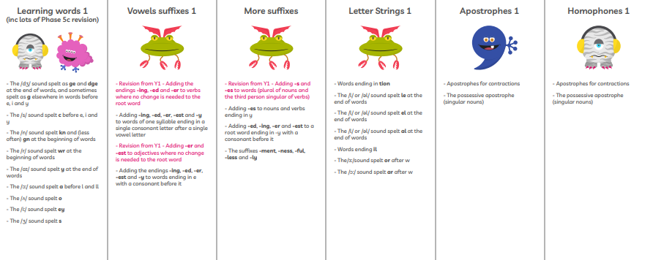
SPAG  Yr 3 | Revise: Use of capital letters, full stops, question marks and exclamation marks to demarcate sentences  Use of the forms a or an  Speech bubbles and speech, expanded noun phrases  Using conjunctions for co-ordination and subordination  Writing sentences with more than one clause  Prepositions and conjunctions  Apostrophes for contraction and possession | Expressing time, place and cause using conjunctions [for example, when, before, after, while, so, because],  adverbs [for example, then, next, soon, therefore], | Introduction to paragraphs as a way to group related material  Headings and sub-headings to aid presentation  Use of the present perfect form of verbs instead of the simple past [for example, He has gone out to play contrasted with He went out to play] | Introduction to inverted commas to punctuate direct speech | prepositions [for example, before, after, during, in, because of]  Word families based on common words, showing how words are related in form and meaning [for example, solve, solution, solver, dissolve, insoluble] | Formation of nouns using a range of prefixes [for example super–, anti–, auto–]
Year 3 Spelling/  phonics revision | 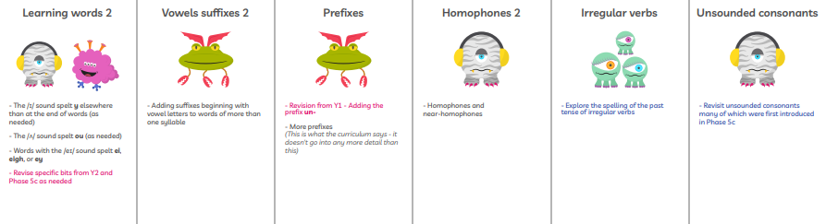
Maths  White rose mixed year Y2/3 | 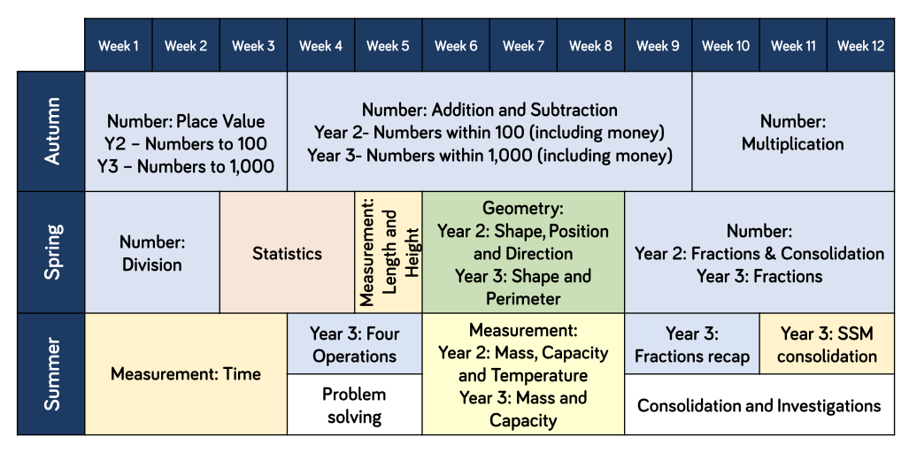
Science | Living things and their habitats: yr 2  Beatrix Potter  *explore and compare the differences between things that are living, dead, and things that have never been alive  *identify that most living things live in habitats to which they are suited and describe how different habitats provide for the basic needs of different kinds of animals and plants, and how they depend on each other  *identify and name a variety of plants and animals in their habitats, including microhabitats  *describe how animals obtain their food from plants and other animals, using the idea of a simple food chain, and identify and name different sources of food | T2+3  Every Day Materials yr 2  • Find out how the shapes of solid objects made from some materials can be changed by squashing, bending, twisting and stretching.  • Identify and compare the suitability of a variety of everyday materials, including wood, metal, plastic, glass,  brick/rock, and paper/cardboard for particular uses. |  | Plants Yr 2  • Observe and describe how seeds and bulbs grow into mature plants.  • Find out and describe how plants need water, light and a suitable temperature to grow and stay healthy.  Plants: Yr 3  identify and describe the functions of different parts of flowering plants: roots, stem/trunk, leaves and flowers  explore the requirements of plants for life and growth (air, light, water, nutrients from soil, and room to grow) and how they vary from plant to plant  investigate the way in which water is transported within plants  explore the part that flowers play in the life cycle of flowering plants, including pollination, seed formation and seed dispersal | T5+6  Forces: Yr 3  Issac Newton  *compare how things move on different surfaces  *notice that some forces need contact between 2 objects, but magnetic forces can act at a distance  *observe how magnets attract or repel each other and attract some materials and not others  *compare and group together a variety of everyday materials on the basis of whether they are attracted to a magnet, and identify some magnetic materials  *describe magnets as having 2 poles  *predict whether 2 magnets will attract or repel each other, depending on which poles are facing
Art | Painting Landscapes: Turner  • Add white to colours to make tints and black (yr2)  • Mix colours effectively.  • Use watercolour paint to produce washes for  backgrounds then add detail (yr3) |  |  | Digital Photography:  British Photography awards  • Use a wide range of tools to create different textures, lines, tones, colours and shapes. (Yr2)  • Create images, video and sound recordings and explain why they were created. (Yr3) |  | Printing:  Andy Warhol  • Use repeating or overlapping shapes.  • Press, roll, rub and stamp to make prints.(Yr2)  • Make precise repeating patterns.  • Use layers of two or more colours. (Yr3)
DT |  | Construction:  • Use materials to practise drilling, screwing, gluing and nailing materials to make and strengthen products. (Yr2)  • Choose suitable techniques to construct products or to repair items.  • Strengthen materials using suitable techniques.(Yr3) | Textiles:  • Shape textiles using templates.  • Join textiles using running stitch.  • Colour and decorate textiles using a number of techniques (such as dyeing, adding sequins or printing). (Yr 2)  • Select the most appropriate techniques to decorate textiles. (Yr 3) |  | Mechanisms:  • Create products using levers, wheels and winding mechanisms. (yr2)  • Use scientific knowledge of the transference of forces to choose appropriate mechanisms for a product (such as levers, winding mechanisms, pulleys and gears). (Yr3)
History |  | Anglo Saxons:  • Show an understanding of concepts such as civilisation, monarchy, parliament, democracy, and war and peace. (Yr2)  • Describe the characteristic features of the past, including ideas, beliefs, attitudes and experiences of men, women and children. | Vikings:  • Recognise that there are reasons why people in the past acted as they did. (Yr2)  • Give a broad overview of life in Britain from ancient until medieval times.  • Understand the concept of change over time, representing this, along with evidence, on a time line.  • Use appropriate historical vocabulary to communicate, including:  • dates  • time period  (Yr3) |  | The Great Fire Of London  Samuel Pepys  • Describe historical events.  • Describe significant people from the past.  ( yr2)  • Suggest suitable sources of evidence for historical enquiries.  • Use more than one source of evidence for historical enquiry in order to gain a more accurate understanding of history. (Yr 3) | Titanic:  Scott of the Antarctic  • Use artefacts, pictures, stories, online sources and databases to find out about the past.  • Identify some of the different ways the past has been represented.  • Use dates where appropriate.  • Show an understanding of the concept of nation and a nation’s history.  (Yr2)  • Describe different accounts of a historical event, explaining some of the reasons why the accounts may differ.  • Suggest causes and consequences of some of the main events and changes in history.  • Use literacy, numeracy and computing skills to a good standard in order to communicate information about the past. (Y3)
Geography | Sensational Safari (Yr 2 Topic)  • Identify the key features of a location in order to say whether it is a city, town, village, coastal or rural area.  • Name and locate the world’s continents and oceans.  • Understand geographical similarities and differences through studying the human and physical geography of a small area of the United Kingdom and of a contrasting non-European country. (Yr2)  • Name and locate the Equator, Northern Hemisphere, Southern Hemisphere,  • Describe geographical similarities and differences between countries. |  |  | Rainforests: (yr 3 Topic)  • Devise a simple map; and use and construct basic symbols in a key. Use simple grid references (A1, B1). (Yr2)  • Use the eight points of a compass, four-figure grid references, symbols and key to communicate knowledge of the United Kingdom and the wider world. (Yr3) | Magical Mapping: Yr 2 topic)  • Use aerial images and plan perspectives to recognise landmarks and basic physical features. (yr2)  • Use maps, atlases, globes and digital/computer mapping to locate countries and describe features. (Yr3)
Music  Charanga | Let your spirit fly  Year 3 unit 1 | Christmas performance | Glockenspiel 1  Yr 3 unit 2 | Three Little birds  Yr 3 Unit 3 | The dragon song  Yr 3 unit 4 | Bringing us together  Yr 3 unit 5
Spanish  Year 4 cycle A | Vocab- parts of the body  Adjectives to describe.  Asking for Spanish translation  Tiene (have), tambien (too)  Skills- follow a short text | Vocab- zoo animals  Hay (there are/is)  Verb ser (to be)  Es (he/she is)  Quantifiers  Bastante (quite)  Muy (very)  Adjectives  Skills- write a short sentence noun, verb, adjective.  Vocab- Christmas | Vocab- family  Mi (my)  Ask and answer questions about family  Pets  Tengo (I have)  No tengo (I don’t have)  Tambien (too)  Skills- read a phrase aloud  Ask and answer questions  Write simple sentences | Vocab-colours (revision)  Bastante (quite)  Skills- know some Spanish traditions about Easter  Present a short, spoken text  Learn to use a bilingual dictionary. | Vocab- Hobbies  Me gusta (I like)  No me gusta (I don’t like)  Skills- attempt write short phrases from memory.  Recognise positive and negative statements.  Read and understand a short paragraph with familiar vocab. | Vocab- Te gusta?(do you like?)  Revision of hobbies  Skills- conduct a short interview in Spanish.  Vocab- transport  Skills- conduct a survey  Vocab- weather  Quantifiers mucho (a lot)  Un poco (a little)  Clothes items
Essential MFL Skills | In Years 3 and 4 pupils:  • Read and understand the main points in short written texts. • Read short texts independently. • Use a translation dictionary or glossary to look up new words. • Write a few short sentences using familiar expressions. • Express personal experiences and responses. • Write short phrases from memory with spelling that is readily understandable. • Understand the main points from spoken passages. • Ask others to repeat words or phrases if necessary. • Ask and answer simple questions and talk about interests. • Take part in discussions and tasks. • Demonstrate a growing vocabulary. • Describe with some interesting details some aspects of countries or communities where the language is spoken. • Make comparisons between life in countries or communities where the language is spoken and this country.
RE  (Yr3 cycle) | CREATION/ FALL:  What do Christians learn from the creation story? | How do festivals and family life show what matters to Jewish people? | People of God. What is it like to follow God? | Who is Muslim and how do they live? How do festivals and worship show what matters to a Muslim? | Christianity:  The Gospel  What kind of world did Jesus want? | How and why do religious and non-religious people try to make the world a better place?
PE | Hockey  Multiskills | Tag Rugby  Gym | Netball  FUNdementals | Dodgeball  Dance | Cricket  Tennis | Athletics  Rounders
Computing  (Miss Withey) | Collect:  Exploring the digital world  Develop understanding of digital devices, how technology can help them. Using school devices and their applications.  • Use a range of applications and devices in order to communicate ideas, work and messages. (Yr3) | Communicate:  Connecting and sharing  Creating blogs, using iPads/cameras to create media  • Contribute to blogs that are moderated by teachers.  • Understand that comments made online that are hurtful or offensive are the same as bullying.( Yr 3) | Code:  Coding a Viking invader  Using scratch to create a simple invasion game  Yr 2 (+Yr 1 skills): Draw- • Control when drawings appear and set the pen colour, size and shape.  Events-• Specify user inputs (such as clicks) to control events.  Yr 3:  Motion-• Use specified screen coordinates to control movement.  Looks-• Set the appearance of objects and create sequences of changes. | Collect:  Rainforest researchers  Use pictograms and create their own pictograms/  databases based on rainforests | Code:  Quiz masters  Using scratch to program a quiz based on ‘The Great Fire of London’  Yr 2 (+Yr 1 skills):  Control-• Specify the nature of events (such as a single event or a loop).  Sensing-• Create conditions for actions by waiting for a user input (such as responses to questions like: What is your name?).  Yr 3:  Sound-• Create and edit sounds. Control when they are heard, their volume, duration and rests. | Communicate:  Titanic experts  Create their own ‘Titanic’ information poster using various publishing software  • Use a range of applications and devices in order to communicate ideas, work and messages. (Yr2)  • Use some of the advanced features of applications and devices in order to communicate ideas, work or messages professionally. (Yr3)
PSHE (pink curriculum)  and Relationships and Sex Education | Citizenship and British values |  | Growing Up (PSHE)  R+SE:  Lesson 1 | Internet safety  R+SE:  lesson 2 | Social issues:  What is happening in my community  R+SE:  lesson 3 | Financial Capability  R+SE:  lesson 4

